

NATIONAL UNIVERSITY OF TECHNOLOGY
NUTECH

Course Title:Programming Fundamentals
Department:Computer Science
Name:M Abdullah Habib
Nutech ID:F26608011
Instructor:Lec Sajid Ali
Course Code:CS 120
Semester:Fall-2026

Assignment No:1
Code:
#include <iostream>
#include<iomanip>
using namespace std;
int main()
{ //Declare and integer variable and initialize with 10
int a=10;
//Declare a character variable and initialize it with 'A'
char ch='A' ;
//Pre-increment a and type cast result ot float
float f1=(float)++a;
cout<<"f1="<<f1<<endl;
//Step 4:Post Decrement a and type cast original Value to double
double d1=(double)a--;
cout<<"d1="<<d1<<endl;
//Step 5:Increment ch and type cast it to integer
int incrementedChar=(int)++ch;
cout<<"Incremented Character="<<ch<<endl;
cout<<"Integer value="<<incrementedChar<<endl;
//Step 6:decrement ch twice
--ch;
--ch;
//Type cast the final character back to integer
int finalvalue=(int)ch;
cout<<"Final integer value="<<finalvalue<<endl;
return 0;}

Output:
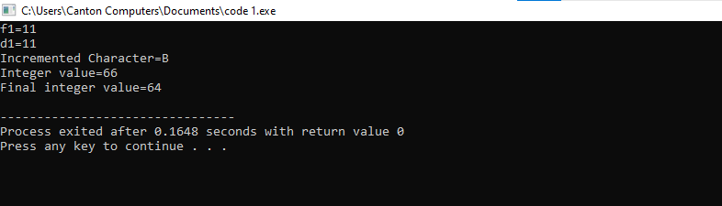
Report:
- The variable “a” is declared with integer datatype and initialized with 10.
- Variable ch is declared with datatype character and initialized with value“A”.
- Pre-increment is used on variable “a”.
- Variable “a” is typecast to variable f1 of float datatype.f1 is displayed on screen.
- Post decrement operator is used on variable “a”.
- Variable “a” is type casted to variable d1 of double datatype.d1 value is displayed on screen.
- Increment operator is used on variable”ch”.
- Variable ch is type casted to variable incremented character of integer datatype.Incremented character is displayed on screen.
- Type casted value is also displayed.
- Twice Decrement operation is perfoamed on ch variable.
- Character variable is type cased into integer datatype.Final value is displayed on screen.Type casted value is also displayed.

